

**Implementation of IoT based Smart City System using Node MCU**

*A project report submitted in partial fulfilment of the requirement*

*for the award of degree of*

# BACHELOR OF TECHNOLOGY

*In*

# ELECTRONICS AND COMMUNICATION ENGINEERING

*Submitted by*

|  |  |
| --- | --- |
| **P. UDAY KIRAN**  **(19341A04B5)** | **P. SOWMYA**  **(19341A04C2)** |
| **N. SIVAJI**  **(20345A0410)**  **P. MAHESH**  **(19341A04C9)** | **K. SUDHEER NAIDU**  **(19341A0480)** |
|  | |

*Under the esteemed guidance of*

**Dr. D. SURESH**

Assistant Professor, Dept. of ECE

GMR Institute of Technology

**An Autonomous Institute Affiliated to JNTUK, Kakinada**

(Accredited by NBA, NAAC with ‘A’ Grade & ISO 9001:2008 Certified Institution)

**GMR Nagar, Rajam – 532 127,**

**Andhra Pradesh, India**

**NOVEMBER 2022**



**Department of Electronics and Communication Engineering**

**CERTIFICATE**

This is to certify that the project entitled **Implementation of IoT based Smart City System using**

**Node MCU** submitted by **P. UDAY KIRAN (19341A04B5), P. SOWMYA (19341A04C2),**

**N. SIVAJI (20345A0410), K. SUDHEER NAIDU (19341A0480), P. MAHESH (19341A04C9)** has been carried out in partial fulfilment of the requirement for the award of degree of **Bachelor of Technology** in **Electronics and Communication Engineering** of **GMRIT, Rajam** affiliated to **JNTUK, KAKINADA** is a record of bonafide work carried out by them under my guidance & supervision. The results embodied in this report have not been submitted to any other University or Institute for the award of any degree.

**Signature of Supervisor Signature of HOD**

**Dr. D. SURESH Dr. V. JAGAN NAVEEN**

Assistant Professor Professor & Head

Department of ECE Department of ECE

GMRIT, Rajam. GMRIT, Rajam.

The report is submitted for the viva-voice examination held on ………………...

Signature of Internal Examiner Signature of External Examiner

# ACKNOWLEDGEMENT

It gives us an immense pleasure to express deep sense of gratitude to my guide, **Dr. D. Suresh,** Assistant Professor, Department of Electronics and Communication Engineering of whole hearted and invaluable guidance throughout the project work. Without his sustained and sincere effort, this project work would not have taken this shape. He encouraged and helped us to overcome various difficulties that we have faced at various stages of our project work.

We would like to sincerely thank our Head of the Department, **Dr. V. Jagan Naveen**, for providing all the necessary facilities that led to the successful completion of our project work.

We would like to sincerely thank our Associate Dean Academics, **Dr. M. V. Nageswara Rao**, for extending his support with all the necessary facilities that led to the successful completion of our project work.

We would like to take this opportunity to thank our beloved Principal, **Dr. C. L. V. R. S. V Prasad**, for providing a great support to us in completing our project and for giving us the opportunity of doing the project work.

We would like to take this opportunity to thank our beloved Director Education, **Dr. J. Girish**, for providing all the necessary facilities and a great support to us in completing the project work.

We would like to thank all the faculty members and the non-teaching staff of the Department of Electronics and Communication Engineering for their direct or indirect support for helping us in completion of this project work.

Finally, we would like to thank all of our friends and family members for their continuous help and encouragement.

**P. Uday Kiran (19341A04B5)**

**P. Sowmya (19341A04C2)**

**N. Shivaji (20345A0410)**

**K. Sudheer Naidu (19341A0480)**

**P. Mahesh (19341A04C9)**

**ABSTRACT**

By 2050, there will be 20 billion people on the planet, and it is predicted that they will use 71% more natural resources, which will increase power consumption and make sustainable development more difficult. Smart cities will therefore be required to address these issues and foster economic development. Although there are many various energy sources, including thermal energy, wind, solar, and tidal energy, that can be utilised to generate electricity, the current generation has trouble lowering the quantity of power used. An efficient solution that seeks to maximise the use of energy resources and has objectives for sustainable energy is provided by smart cities (renewable energy and energy-efficient technologies). This paper demonstrates the implementation of a smart city through the Internet of Things using the Node-MCU device. The major objective of this project is to improve living standards by developing smart home automation system, smart street light controller, and smart irrigation system that conserve power and water resources. The implementation of this project enhances the economic infrastructure in a way that is both cost-effective and produces successful smart outcomes.

|  |  |  |  |
| --- | --- | --- | --- |
| **TABLE OF CONTENTS**    **CONTENTS** | | | **PAGE NO.** |
|  | | |  |
| **ACKNOWLEDGEMENT**  **ABSTRACT**  **LIST OF FIGURES** | | | iii  iv  vi |
|  | | |
| 1. **INTRODUCTION**    1. **Introduction of IoT**    2. **Introduction of Smart Home Automation System**    3. **Introduction of Smart Irrigation System**    4. **Introduction of Automatic Street light Controller** 2. **LITERATURE SURVEY** 3. **METHODOLOGY**    1. **Implementation of Smart Home Automation System**    2. **Implementation of Smart Irrigation System**    3. **Implementation of Automatic Street light controller** | | | 12  27 |
| COMPONENTS DESCRIPTION   * 1. **Description of Node MCU**   2. **Description of Relay Module**   3. **Description of Blynk smartphone app**   4. **Description of Soil Moisture Sensor**   5. **Description of LDR Module**  1. **RESULTS** 2. **CONCLUSION AND FUTURE WORK**   **APPENDIX**  **REFERENCES**  **CONFORMATION LETTER**  **PUBLICATION CERTIFICATES** | | | 42  46  51 |
|  |
|  |  |

**LIST OF FIGURES**

|  |  |  |
| --- | --- | --- |
| **FIGURE NO.** | **TITLE** | **PAGE NO.** |
| 1.1  1.2  1.3  3.1  3.2  3.3  4.1  4.2  4.3  4.4  4.5  4.6  4.7  4.8 | Smart Home Automation System  Smart Irrigation System  Automatic Street Light Controller  Block Diagram of Smart Home Automation System  Block Diagram of Smart Irrigation System  Block Diagram of Automatic Street Light Controller  Node MCU  Pin Diagram of Node MCU  Relay Module  Soil Moisture Sensor  Working Diagram of Soil Moisture  DHT11 Sensor  LDR Module  Working of IR sensor | 10  12  13  24  25  26  27  28  32  34  35  37  39  40 |

# INTRODUCTION

IoT (Internet of Things) is a concept that allows physical objects to communicate with one another and connects them to the internet network so that they can be remotely controlled by websites and mobile applications. In order to help the city resident’s various problems related to power consumption, a smart city is constructed which uses a variety of IoT devices. IoT is used to gather and process data from numerous actuators and sensors, after which it is wirelessly transmitted to smartphones or computers. IoT offers a variety of applications and has the ability to meet customer requests for services and products. The conventional switch systems will make a good transition to this technology. IoT can communicate without the need for a human presence to operate the switches. Some preliminary IoT applications have been already developed in healthcare, transportation, and automotive industries. Although Internet of Things (IoT) technologies are still in their infancy, there have been several recent advances in the connection of physical things to online sensors. Many concerns, including infrastructure, communications, interfaces, protocols, and standards, are involved in the development of the Internet of Things.

The goal of the smart cities initiative is to use technology, particularly that which produces intelligent results, to raise peoples' standards of living and economic prosperity. One of the benefits of a smart city is the ability to improve infrastructure and services via the application of innovative technologies. For instance, reducing the risk of disasters in certain locations, utilizing fewer resources, and offering affordable services that promote smart living.

Smart Living is the improvement of quality of life through practical responses to the mutating demands of the information and technological era. It consists of energy-saving appliances with remote controls that may be used to remotely ON and OFF any equipment. Here, we can make use of gadgets that show weather data like temperature, humidity, amount of rain, and wind speed. Washing machines with temperature control and self-cleaning feature could make use of smart home appliances to monitor the laundry remotely. In order to determine burglars, safety monitoring includes watching security cameras and home alarm systems for opening doors. In order to reduce expenditures and resource usage, some of the gadgets are also used to monitor water and electricity use in the home.

Safety tools for smart living in smart cities include fire control, emergency warning services, and digital video monitoring. Here, transportation is provided by intelligent highways and roads that include alerts and detours for any unforeseen circumstances.

IoT gadgets of various kinds are used in smart cities to solve problems and offer assistance to urban residents. The Internet of Things (IoT) is a group of networks, things, and tools that are linked together online. Both internally and externally, it engages in environmental interaction. IoT reacts to the environment after sensing it. It provides the environment with cutting-edge methods and so raises the standard of existence. IoT enables the gadgets to speak to one another both physically and virtually. The Internet of Things (IoT) enables the environment to become intelligent and connect with any device at any time. These days, individuals desire to converse online with all types of inanimate objects. IoT is used to gather and process data from various actuators and sensors [4], which is then wirelessly transmitted to smartphones or computers. Applications utilizing IoT are developing, and in each of these applications, IoT plays a crucial role in raising living standards. Examples of these applications include home appliances, smart energy, the environment, industries, etc., and creating a welcoming environment [4]. IoT is employed in the supply chain, transportation, automation, and remote monitoring to give it a more professional appearance. IoT significantly improves people's quality of life, is extensively adopted by the device network, and creates a new ecosystem for the creation of applications by anticipating the growth of the market in its infancy. IoT has the capacity to meet the needs and demands of people in our quick-paced environment. The work of IoT smart systems and its applications is presented in this project. The use of smart technologies and data to understand sustainability development is another definition of a "smart city." So, the Internet of Things is being implemented wisely here. These days, the IoT is being used all around the world. The IoT is implemented in smart city initiatives using a variety of electrical devices and internet protocols. This smart city project reduces carbon dioxide emissions while also advancing autonomous driving technology. The Internet of Things improves safety and security-related issues and raises the city's intelligence. It's crucial to have a high-quality architecture for the IoT to continue to work. IoT adoption, however, faces a number of difficulties, including security concerns. One of the main applications of IoT is sensor. The sensor structure is deliberated to process accurately and quickly without human intervention if any need they can request to the framework through messages which will in turn respond with the information needed by the user. The affairs of sensors related to the interconnection of terminals and examining the request, declining the terminals and referring the progress of transmission under the condition of the remote site.

This report discusses three major sectors: smart home automation, smart irrigation, and automatic streetlight controller.

Home automation is the term used to describe the automatic control of household appliances. Various systems are used for home automation, each of which is based on a different microcontroller and uses a different set of parameters to monitor and manage the home appliances. The solution enables effective control of household appliances using IoT sensors and other communication tools. Anywhere in the world, we have access to mobile devices, laptops, and the internet to operate home equipment. The system is used to manage a variety of tube lights, fans, home appliances, electrical motors, air conditioners, and air heating systems, among other things. are easily managed by web-enabled or internet-capable devices. These kinds of systems are becoming more and more common since they are easier to build and offer versatile functionality that can be quickly customized to suit individual needs. For this reason, IoT systems are very valuable and in high demand. In addition to helping those who are disabled and can no longer walk, patients, or elderly people who spend most of their time in bed, IoT systems also benefit those who live alone in their homes.

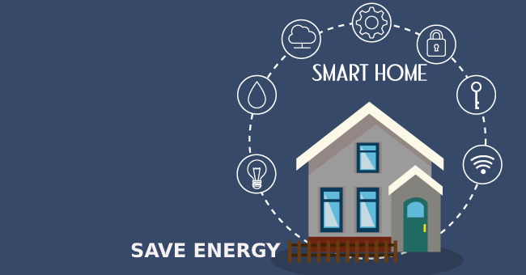

Fig 1.1 Smart Home Automation System

The main portion of India's population depends mostly on agriculture, which also contributes significantly to the country's economy. However, India's agro sector still has to develop and promote technological engagement and usability. Although the Indian government has also made a few efforts to provide farmers with internet and mobile messaging services connected to agricultural queries and agro vendor information. IoT is transforming the agricultural industry and giving farmers the tools, they need to combat the enormous challenges they confront. Agriculture must find a way to deal with the growing water shortages and limited land availability while also satisfying the growing consumption needs of the global population. The foundation of the Indian economy is agriculture. As the world's population is expanding quickly today, agriculture is becoming more crucial to supplying the demands of the human race. Agriculture does, however, require irrigation, and since we use more water each year than we do for precipitation, growers must develop ways to do so while still getting the best output possible. However, in the modern period, farmers have been adopting irrigation techniques with human controls, irrigating the ground at regular intervals.

Statistics show that 85% of the world's freshwater resources are used by agriculture, and due to population growth and rising food demand, this percentage will continue to dominate water usage. Strategies for the sustainable use of water, including technical, agronomic, managerial, and institutional improvements, must be developed immediately. Internet-based agricultural irrigation is based on guidelines for crop water needs. We can minimize water waste and make the most of scientific irrigation technologies by utilizing Internet and sensor network technology [13]. As a result, it can significantly improve water usage and raise water productivity. With the use of the Internet of Things (IoT), a mobile device can be used to check on a gadget's operation. The Internet of Things (IoT) is concerned with linking talking devices that are put in various places that could be far from one another. The Internet of Things (IoT) is a type of network technology that gathers data from various sensors and enables anything to connect to the Internet in order to exchange data [4].

It can also be used to change the device's status. Additionally, the central processing unit will have a communication device for relaying data from the sensors to the user's device. A higher-level communication tool, such as a Wi-Fi module, will be used for this. The central module transforms the data it has processed into relaying to the user relevant facts. A handheld device, such as a cell phone or tablet, can be used by the user to examine the data. These days, farming is really concerned about water scarcity. This technology provides farmers with an automated irrigation system that is based on soil moisture to irrigate their crops effectively.

The planned system is built to stop extra water from flowing into agricultural regions. Temperature, moisture, and humidity readings are continuously recorded using sensors, and these readings are sent to the designated IP address. Data from that allocated IP address is continuously collected by an Android application. The motor is controlled by the relay connected to the Node MCU microcontroller after the soil moisture measurements have exceeded a specific limit. The Android app is a straightforward menu-driven program with 4 settings. This provides values for moisture, temperature, and humidity as well as motor status. The present status of the pump is shown by the motor status.



Fig 1.2 Smart Irrigation System

Street lighting is one of the main energy consumers in any city. Even during the day, when street lights are not necessary, it is regularly observed that these lights are left on, in violation of the law requiring energy saving. This constant lighting increases the cost of electricity while also polluting the environment. Public transportation at night or in very dim daylight is a crucial application for streetlights. As a result, sustaining safe transportation in our daily lives depends on the design and management of street lighting. Researchers have focused their efforts on finding ways to use less energy while also reducing environmental pollutants. An evaluation was conducted in order to demonstrate a power-saving street lighting system. By examining several street lightings lights such as incandescent, CFL, high-intensity discharge, and light-emitting diode, consumption in comparison to conventional lighting systems has revealed that LEDs are more effective than other lighting systems. An energy conservation case study also revealed that, despite a higher initial investment, the operating life of an LED system is comparably longer than that of a conventional fluorescent lighting system, leading to greater long-term initial investment savings and decreased annual energy consumption. Since the majority of the energy sources, we rely on, such coal and natural gas, cannot be replaced, we must save or preserve energy. Once we've used them up, they're permanently lost. Electricity conservation is crucial; instead of utilizing the power when it is not essential, it should be turned off. "STREET LIGHT" is one of the primary power-consuming factors in any metropolis. The majority of the time, street lights include a controller with an LDR that senses ambient light. The lights are turned ON if the ambient light falls below a particular threshold. The pic18f452 microcontroller is connected to a light-dependent sensor that tracks the sun's brightness. When the sensor detects darkness, an LED will turn on, and when it detects light, the LED will turn off.

# General Guidelines | NYC Street Design Manual

# Fig 1.3 Automatic Street Light Controller

# 

# 2. LITERATURE SURVEY

# Android Based Smart Home System with Control via Bluetooth and Internet Connectivity

This essay explains how to put a trustworthy, conveniently accessible, affordable, compact, and inexpensive system into practice. Home appliances can be controlled using a single touch on the Android mobile app for a home automation system that is based on an android phone.

In our daily lives, we use mobile phones a lot. We can utilize a broad variety of programs on smartphones. User authentication, Bluetooth and internet connectivity, a security and fire system with a siren, and automated control of household appliances are all elements of this paper.

**Advantages:**

* Bluetooth is simple to use, quick, and widely accessible.
* Communication between the user and devices is reliable.

**Drawbacks:**

* Bluetooth connections might become lost under certain circumstances.
* Bluetooth's bandwidth is limited.
  1. **An Information Framework for Creating a Smart City Through Internet of Things**

In this study, a framework for implementing smart cities via the Internet of Things is presented (IoT). The framework is a transformative component of the current cyber-physical system and incorporates the entire urban information system, from the sensory level and networking support structure through data management and Cloud-based integration of respective systems and services. This Internet of Things (IoT) vision for a smart city is applied to a noise mapping case study to illustrate a novel approach for improving and delivering crucial city services.

**Advantages:**

* It uses an RFID system with a long range, allowing a transmitter to communicate across greater distances.
* Wiring is not required because a wireless sensor network is used.

**Drawbacks:**

* Setting up an RFID system is more expensive.
* High-speed communication cannot be accomplished with a wireless sensor network.
  1. **A Survey on the Applications of Smart Home Systems**

This article offers an overview of applications for smart homes along with numerous recommendations. The apps are broken down into a variety of categories, each with a brief explanation of their goal, benefits, and restrictions. Smart card-based security, voice and speech recognition-based security, handwriting recognition-based security, and password-based security are some examples of applications. Additionally, they found a number of applications, including the Fire Alert System, temperature and humidity monitoring, water management and leak detection, air quality monitoring, etc.

**Advantages:**

* Smart homes save time, money, and energy, which helps to raise quality of life.
* A smart house offers improved security.

**Drawbacks:**

* If anyone has the password for the smart card-based security system, anyone can use it and the card can be lost or stolen.
* When there is background noise, voice and speech recognition-based security cannot function effectively.

# Systematic Survey on Smart Home Safety and Security Systems Using the Arduino Platform

In recent years, the relevance of smart home safety and security systems has increased due to their significant contribution to lowering and averting losses in resources and human life brought on by unfavorable events that could arise while homeowners are away from their houses. This essay argues that using a fire alarm system is essential for safeguarding homes from fires and gas leaks. Motion detection systems have been developed and are used to safeguard homes against thieves.

**Advantages:**

* Motion sensors are inexpensive and durable.
* Installing a motion detection system is simple.

**Drawbacks:**

* High temperatures prevent the operation of passive motion sensors.
* A passive type sensor is insensitive to an object moving very slowly.

**2.5 Ecological Terminal Design of Smart Home**

In light of the gradual acceptance of intelligent technology, this essay investigates more efficient and friendly ways to preserve the quality of the home environment. The study has significant theoretical and practical implications: theoretically, it contributes to the development of a man-machine interactive evaluation system for Smart Home and household ecological research, offering a friendly and healthy design concept for the future of Smart Home life; practically, it suggests a product design method for preserving the ecological family environment by fusing contemporary intelligent technology.

**Advantages:**

* The ZigBee wireless network technology has a low complexity and power need.
* Humidification and some air contaminants can be monitored using HEPA technology.

**Drawbacks:**

* The biggest disadvantage is that Zigbee technology deployment might be pricey.
* Other pollutants including gases, vapors, chemicals, etc. cannot be measured by HEPA filters.

**2.6 Design and Implementation of a Smart Home System Using Multisensory Data Fusion Technology**

This study integrates wearable intelligent technology, artificial intelligence, and sensor fusion technology to create a multimodal data fusion technology-based smart home system. Additionally, an intelligent monitoring system is employed to offer real-time data on the smart home system, including environmental temperatures, status of domestic appliances, and signals of human movements. A wearable inertial sensing module, a multisensory circuit module, an information processing module, a decision-making module, an intelligent monitoring interface, and a home appliance plant make up the suggested smart home system.

**Advantages:**

* The uses for wearable technology are numerous.
* The more accurate sensor fusion technique combines all of the pertinent data from various photos into a single object.

**Drawbacks:**

* The sensor fusion system has a significant installation cost.
* Wearables' battery life is limited.

**2.7 Internet of things for ubiquitous smart home system**

This article provides an example of a low-down rate controlling system that makes use of an embedded micro-web server and IP connectivity to allow users of Android-based smart phones to access household appliances remotely. In this paper, the routing protocols AODV and DSR are employed. This is a stationary micro-web server with internet protocols for managing and monitoring appliances using an Android-compatible smartphone. A hardware interface component, an Arduino Uno with an Ethernet

shield used as a micro web server, and an Android phone with Android function tools make up this system.

**Advantages:**

* The Arduino Uno is a low-cost, open-source piece of hardware.
* The AODV protocol has a short setup time for connections.

**Drawbacks:**

* The primary flaw of Arduino Uno is that it can only run one sketch or application at a time.
* The AODV protocol might occasionally result in needless bandwidth usage.

**2.8 A Novel Secure IoT-Based Smart Home Automation System Using a Wireless Sensor Network**

This article put out WSN-based, secured IoT applications for home automation. In WSNs, an effective security mechanism based on effective key generation mechanisms that could achieve all important data security criteria and consumes less processing time for data encryption is strongly needed due to the limited computational capability of sensor nodes. This work develops the security algorithm TBSA, which is based on a quick and effective key generation process. The proposed IoT integrates low power Wi-Fi and the proposed TBSA in WSNs with the internet to provide additional advantages, including increased coverage range and the ability to support a large number of sensor nodes due to the use of low power Wi-Fi module; it also consumes less processing time for data encryption due to the use of the proposed TBSA algorithm. The experimental data from the hardware implementation has clarified that the suggested TBSA algorithm is more energy-efficient for data encryption than all compared methods.

**Advantages:**

* Implementing data encryption is inexpensive.
* Data transfer between the source and destination nodes is authenticated specifically using the authentication key.

**Drawbacks:**

* It is challenging to transmit the data gathered from the sensor nodes to the correct destination node.
* Data processing, time, use of various encryption and decryption techniques, and other resources are all needed for data encryption.

**2.9** **Design and Implementation of a Home Automation System Based on Wi-Fi**

The design and prototype implementation of a novel home automation system using Wi-Fi technology as the network architecture connecting its components are presented in this study. The system offers a scalable and widely coverable device with the aid of a web server and a LAN connection. The system is extremely sophisticated since it makes use of a data-storage server and a less expensive Wi-Fi connection. Users and system administrators can manage and control system code locally (LAN) or remotely (internet). Most of the time, a microcontroller is used to operate the devices. The primary goals of this essay are cost reduction and energy conservation in the natural world.

**Advantages:**

* Due to wireless technology, a large number of mobile devices can be connected to the system from any location in the world.
* Reduces wiring significantly.

**Drawbacks:**

* The limitation of WIFI technology's range is a negative.
* Because of its complicated nature, a microcontroller cannot directly interact with a higher power device.

**2.10 Dual Mode Self Controlled Irrigation System for Home**

There are several stages in the development of a sapling into a plant and a plant into a tree, with irrigation being one of the most important and early ones. The biggest problem today is overwatering your plants. Each type of plant has a specific amount of water it needs to survive, and overwatering a plant can be disastrous. Overwatering severely harms plants and could cause a general deterioration in them. Not all dry surfaces indicate a need for water. Although it appears to have enough of water, your plant is wilting. Diseases like edema can kill a plant by rapidly absorbing water, which can result in the development of blister-like patches. This study describes a system that uses a timer to automatically control the watering intensity. Additionally, determine whether the nearby soil requires extra water by looking at it. The operator will set the built-in timer and determine how long the water regulation will take place. Additionally, this device might be controlled wirelessly by our mobile smartphones, providing the plant with a sufficient flow of water according to user demand and soil requirements.

**Advantages:**

* Save water waste to significantly reduce costs.
* This technology can be wirelessly controlled by our mobile smartphones.

**Drawbacks:**

* The cost of a smart irrigation system is somewhat high.
* Not appropriate for some crops.

**2.11 Smart irrigation with embedded system**

The irrigation system suggested in this study is clever and sophisticated, and it may be used to regulate the irrigation or watering of flowering plants. It manages plant watering automatically, minimizing the need for human involvement. This mostly addressed water waste, which is a major modern challenge. Additionally, it contributes to time savings, financial efficiency, environmental protection, cheap operation and maintenance costs, and effective irrigation services. The prototype system is made to be small and sustainable by utilizing the open-source Raspberry Pi platform. The system features a sensor that gauges the soil's moisture content and switches relays that regulate solenoids in accordance with needs. At various moisture levels, the model presented produced the anticipated outcomes.

**Advantages:**

* This essay offers environmental defense.
* Effective watering service that requires less maintenance.

**Drawbacks:**

* Due to the utilization of Raspberry Pi, implementation costs are considerable.
* Windows was incompatible with the Raspberry Pi.

**2.12 IoT based smart irrigation monitoring and controlling system**

In this research, an IoT-based system that employs real-time input data is proposed. Utilizing a wireless sensor network, a smart farm irrigation system employs an Android phone for remote drip monitoring and control. Between sensor nodes and the base station, Zigbee is utilized for communication. Web-based Java graphical user interface is used to handle and display real-time sensed data on the server. Field irrigation systems may be remotely monitored and controlled on an Android phone, reducing the need for human interaction. A desirable answer to the massive volume of data produced by the wireless sensor network is cloud computing. In order to monitor and manage a group of sensors and actuators to determine the plants' requirement for water, this study suggests and tests a cloud-based wireless communication system.

**Advantages:**

* With cloud-based Smart Irrigation systems, up to 50% of water used for landscape irrigation can be saved.
* The soil moisture sensor reduces the need for fertilizer and boosts farmer profitability.

# Drawbacks:

# If the internet connection is sluggish, there may be a potential that problems will arise when storing the data.

# In sandy soils, soil moisture sensors are less accurate.

# 2.13 Optimal Demand Response Capacity of Automatic Lighting Control

# Demand response programs aim to modify regular electric power consumption patterns of consumers in response to incentive payments made by utilities to encourage reduced consumption during peak hours or when the dependability of the power system is threatened. While earlier research has extensively examined the potential for providing demand response in buildings by regulating the load at air conditioners, water heaters, and other household appliances, it has not provided strategies for utilizing the full demand response potential of automatic lighting control systems. Addressing this deficiency is a significant research issue because lighting systems account for a significant portion of the overall energy utilized in buildings. As a result, in this study, we propose adopting a methodical optimization-based technique to assess the autonomous lighting control systems capacity to adapt to demand in commercial and office buildings.

# Advantages:

# Overheating is less likely, and the risk of accidents is also reduced.

# Reduces labor costs and requirements.

# Drawbacks:

# The automatic street light system's rechargeable batteries need to be changed a few times.

# PV panels may collect snow, dust, or moisture, which could impede their ability to produce energy.

# 2.14 IoT Enabled Crop Prediction and Irrigation Automation System Using Machine Learning

# The objective of the study is to design and develop an automated crop yield maximization system with an irrigation automation process using the Internet of Things (IoT) and machine learning. The proposed study focuses on the maximization of crop yield and profits of the farmer using crop prediction and automation of the irrigation process leading to water conservation. The proposed framework likewise gives farmers an assortment of alternatives of crops that can be developed and an integrated automatic irrigation subsystem can be programmed to discharge more precise amounts of water in a targeted area, which promotes water conservation and avoids significant water wastage.

# Advantages:

# Utilizing crop prediction can boost a farmer's crop productivity and earnings.

# Encourages water conservation and prevents major water waste.

# Drawbacks:

# The proposed system is only capable of measuring crop production performance.

# The proposed system is difficult to implement.

# 2.15 Smart scheduling on cloud for IoT-based sprinkler irrigation

# The purpose of this paper aims to reduce the manpower, electricity, and water consumption for irrigation. The IoT-based smart irrigation system designed with various sensors to collect farm field data, and stored all the data in the cloud for scheduling the irrigation.

# Advantages:

# Decreases the use of electricity, water, and labor, while increasing output.

* Because of sprinkler irrigation**,** the water distribution will always be equal.

# Drawbacks:

# Difficult to implement on a small farm field with different crops.

* There is a requirement of continuous power supply for operating the sprinkler irrigation system.

# 3. METHODOLOGY

This project mainly focuses on three sectors Smart home automation system, Smart irrigation system & Automatic street light controller. Home automation system and irrigation system are implemented using Node MCU which will function well over long distances. Each and every sector has its own features and advantages. Smart home plays an important role in ensuring a high quality of life. Everyone wants to save his/her time and energy along with this there are also handicapped people in houses and they are unable to move frequently in the home for controlling appliances, so using a home automation system enables those all people to control all the appliances easily and comfortably. A major portion of water is consumed by the agriculture sector. In order to save water, time, and money smart irrigation system should be implemented. Saving money and time is also more advantageous for farmers. Automatic street light controller system is implemented using ldr module. The automatic streetlight controller has a photoconductive device whose resistance changes proportional to the extent of illumination, which switches ON or OFF the LED with the use of transistor as a switch. By using this system energy consumption can be reduced because nowadays the manually operated street lights are not switched off even the sunlight comes and also switched on earlier before sunset.

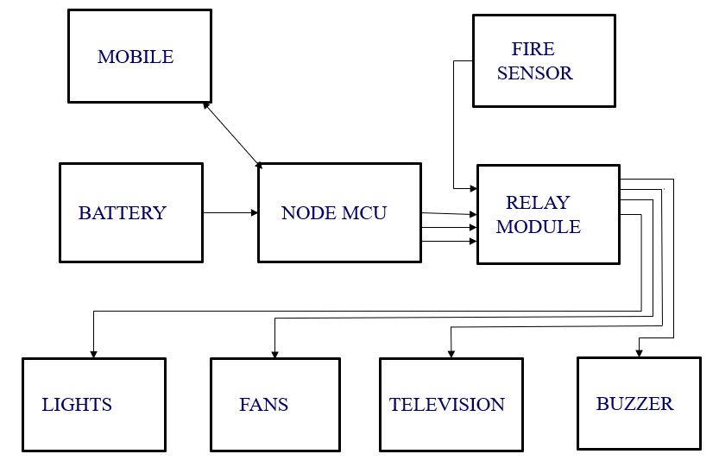

**Fig 3.1: Block diagram of Smart Home Automation System**

The main heart of this project is Node MCU, which is a Microcontroller board having inbuilt WIFI connectivity. In the above fig 3.1, the mobile phone is interfaced with Node MCU and everything is connected to microcontroller board except fire sensor. The fire sensor is directly connected to relay which is used to reduce fire accidents in home. The operating voltage of Node MCU is 3.3v and gives the output with 5v which is not sufficient for the home appliances, so it is given to relay module which produces 230v which is required to control the home appliances. The commands can be given with the mobile phone. So that we can control home appliances with our mobile phones.

The below figure 3.2 shows the implementation of Smart Irrigation System. This system has its own features and advantages. This system is also implemented using IoT device Node MCU.

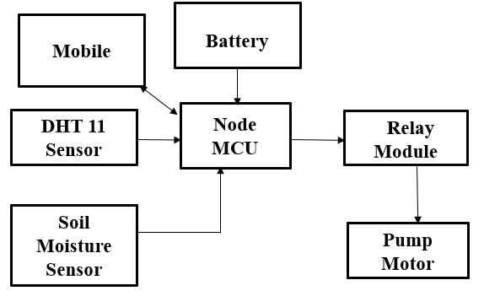

**Fig 3.2: Block diagram of Smart Irrigation System**

The mobile phone is interfaced with the microcontroller board. This implementation includes a soil moisture sensor, which measures the soil's moisture content, and a DHT 11 sensor, which gauges the environment's humidity and temperature. The Node MCU's microcontroller processes the sensor data and transmits it to the phone. The engine can be turned on and off using a mobile phone in accordance with the amount of soil moisture. It is very important to check the moisture content of the soil in frequent times, in order to reduce crop damages.

The below figure 3.3 shows the implementation of Automatic Street Light Controller. This system is implemented using LDR module. LDR stands for light dependent resistor which is used to measure the intensity of light.

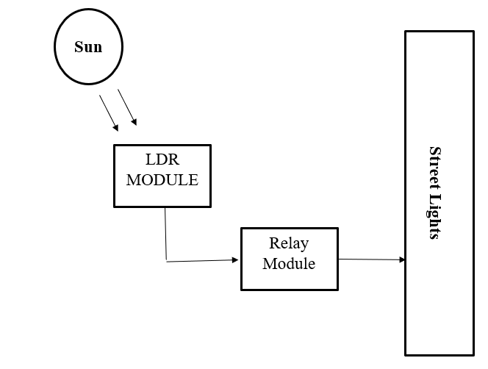

**Fig 3.3: Automatic Street Light Controller**

This implementation does not require any type of IoT device for the operation. The LDR is directly connected to relay which is given to light. Whenever, the intensity of light is low the street light turns on automatically and turns off automatically when the light intensity is more. The operation of this system is shown in fig 3.3.

**4.** **COMPONENTS DESCRIPTION**

**4.1 Node MCU:**

The esp8266 is a self-contained Wi-Fi networking device that can run standalone programs and serves as a bridge from an existing microcontroller to Wi-Fi. This module includes a built-in USB connector and a wide range of pin-outs. Node MCU can be connected to the PC with a micro-USB cable like Arduino. Furthermore, it is now breadboard friendly. Node MCU is an esp8266-based open-source platform that can connect devices and allow data transfer using the wi-fi protocol. Additionally, by providing some of the most important microcontroller features, like as gpio, pwm, adc, and others, it is able to meet the needs of the many missions on its own. The module features a wireless Wi-Fi transceiver that operates in the unlicensed 2400–2484 MHz frequency band.

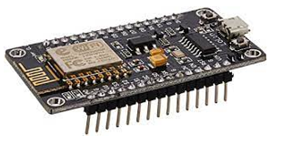

Fig 4.1 Node MCU

**Features:**

* Ease of use
* Programmability using the Arduino IDE or IUA languages
* Available as an access point or station
* Practicable in Event-driven API applications
* Possessing a built-in antenna
* Containing 13 GPIO pins, 10 PWM channels, I2C, SPI, ADC, UART, and 1-Wire.

**Pin Description:**

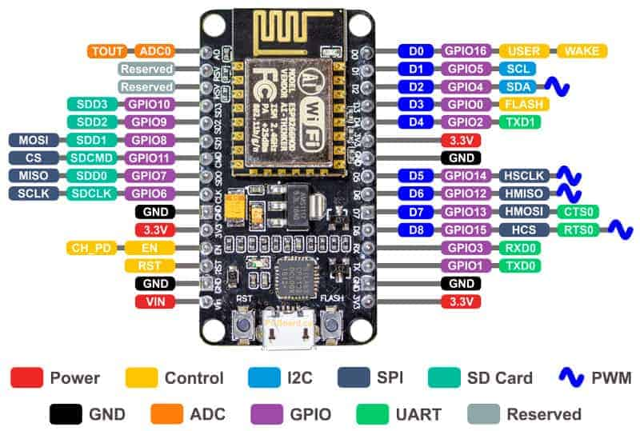

Fig 4.2 Pin Diagram of Node MCU

Img source: <https://www.electronicshub.org/wp->

content/uploads/2021/02/NodeMCU-Pinout-Image.jpg

**Power pins:** There are four power pins. **VIN** pin and three **3.3V** pins.

**•** The Node MCU/ESP8266 and its peripherals can be directly supplied using VIN. The Node MCU module's internal regulator regulates the power sent on VIN; you can also supply 5V controlled to the VIN pin.

• The onboard voltage regulator's 3.3V pins, which can be used to power external components, are its output.

**Gnd:** are the ground pins of Node MCU/ESP8266

**I2C pins:** I2C sensors and accessories are connected using I2C pins. The I2C Master and Slave protocols are both supported. Programmatically implemented I2C interface functionality is possible, and the maximum clock frequency is 100 kHz. It should be remembered that the I2C clock frequency should be greater than the slave device's slowest clock frequency.

**GPIO pins:** The 17 GPIO pins of the Node MCU/ESP8266 can be programmatically allocated to various I2C, I2S, UART, PWM, IR remote control, LED light, and button operations. Each GPIO with digital capability can be adjusted to high impedance, internal pull-up, or internal pull-down. It can also be set to edge-trigger or level-trigger when setup as an input to produce CPU interrupts.

**ADC channel:** A 10-bit precision SAR ADC is included into the Node MCU. ADC may be used to implement the two procedures. Both the input voltage to the TOUT pin and the power supply voltage to the VDD3P3 pin are being tested. However, they cannot be put into action simultaneously.

**UART pins:** Asynchronous connectivity (RS232 and RS485) is provided via the Node MCU/two ESP8266's UART interfaces (UART0 and UART1), which are capable of up to 4.5 Mbps of transmission. You may utilize the TXD0, RXD0, RST0, and CTS0 pins on UART0 to communicate. UART1 (TXD1 pin) only has a data send signal, hence that's why it's typically used for printing logs.

**SPI pins:** Two SPIs (SPI and HSPI) are available on the Node MCU/ESP8266 in slave and master modes. The following general-purpose SPI capabilities are also supported by these SPIs:

4 timing modes of the SPI format transfer

* Up to 80 MHz and the divided clocks of 80 MHz
* Up to 64-Byte FIFO

**SDIO pins:** Secure Digital Input/Output Interface (SDIO), a function of Node MCU/ESP8266, is used to directly interface SD cards. Both 4-bit 50 MHz and 4-bit 25 MHz SDIO versions are supported.

**PWM pins:** The board includes four pulse width modulation channels (PWM). Programmatically implemented PWM outputs can be utilized to power digital motors and LEDs. The PWM frequency range may be adjusted between 1000 and 10000 s. (100 Hz and 1 kHz).

**Control pins:** Control pins are used to operate the ESP8266/Node MCU. These pins include the WAKE pin, the Chip Enable pin (EN), and the Reset pin (RST).

• EN: When the EN pin is pushed HIGH, the ESP8266 chip is enabled. The chip uses very little power when it is pushed LOW.

• RST: The ESP8266 chip may be reset via the RST pin.

• WAKE: The chip is awakened from a deep slumber via a wake pin.

**Specifications:**

* Operating Voltage: 3.3V
* Input Voltage: 7-12V
* Digital I/O Pins (DIO): 16
* Analog Input Pins (ADC): 1
* Flash Memory: 4 MB
* SRAM: 64 KB
* Clock Speed: 80 MHz

**Applications:**

* Internet Smoked Alarm.
* VR Tracker.
* Octopod.
* Serial Port Monitor.
* ESP Lamp.
* Incubator Controller.
* IoT home automation.
* Security Alarms.

**4.2 Relay Module:**

Based on the concept of an electromagnetic appeal, relay modules work. The relay circuit detects the fault current at the same time as the electromagnetic area that generates the transient magnetic location is activated. This magnetic location moves the relay armature during setup or the very final connection. While the little energy relay only has one excellent contact, the high-power relay has two contacts for turning on the switch. The interior component of the relay is shown in the image below. It has an iron core and is coiled via a control coil. The coil gets its power source from the connections between the load and the control switch. Because current travels through the coil, a magnetic field is produced surrounding it. The dual-channel relay module includes switching relays and the required power circuitry, making it simple to add relays into a project driven by a microcontroller. To connect power cords to the module without soldering, use the terminal blocks on the left.

Next, head over to the two relays. The contacts of the relay are rated for 10 amps at 250 volts direct current, 30 volts direct current, or 125 volts direct current, whereas the coil of the relay is rated for 5 volts direct current. The switching transistors amplify the signal from the inputs until it presses the relay. Voltage spikes are prevented from damaging switching transistors by the freewheeling diodes. The fame leds illuminate to indicate switching when the relay is in operation. To further isolate the input from the relays, optocouplers are used. A jumper called the vcc/jdvcc can be used to check isolation. The input jumper's entry and power pins make it simple to connect it to jumper wires, other microcontrollers, and sensors.

**Working Principle:** It functions using the idea of electromagnetic attraction. The electromagnetic field that creates the temporary magnetic field is energized when the relay's circuit detects the fault current. The relay armature is moved by this magnetic field to open or close connections. The high-power relay has two contacts for opening the switch, whereas the small power relay has just one. The figure below depicts the relay's interior part. It has an iron core around which a control coil has been coiled. Through the connections of the load and the control switch, the coil receives power. The magnetic field that surrounds the coil is created as current travels through it. The lower arm of the magnet is drawn to the upper arm by the magnetic field. Therefore, complete the circuit, causing current to flow through the load. If the contacts are already closed, the object moves in the opposite direction to open them.

Types of Relays based on the principle of operation:

1. Electrothermal relay
2. Electromechanical relay
3. Solid State relay
4. Hybrid relay

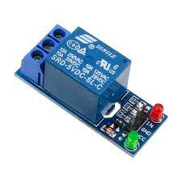  
 Fig 4.3 Relay Module

**Specifications:**

* Voltage supply ranges from 3.75V – 6V
* Quiescent current is 2mA
* Once the relay is active then the current is ~70mA
* The highest contact voltage of a relay is 250VAC/30VDC
* The maximum current is 10A

**Applications:**

* Used in over voltage/under voltage protection system.
* Mains Switching.
* Speed control of motors through start-delta converters.
* Automatic electrical appliances.
* Electrical isolation in between high & low power sources.
* Lights.

**4.3** **Blynk smartphone app:**

The major objective of the blynk platform is to make the creation of mobile phone applications exceedingly simple. You'll learn in this course that creating a mobile app that could represent your Arduino is as easy as dragging a widget and setting up a pin. Blynk allows you to virtually program-free control a motor or led from your smartphone. Don't allow the simplicity of use fool you into thinking that blynk is solely appropriate for straightforward applications, though. Both pros and amateurs use the versatile and effective Blynk tool. You can unlock the storage door, check the soil humidity in your vegetable garden, and turn on the water using your phone. The integration of IoT and AI into boilers and other typical corporate products, as well as improving the integrity and safety of oilfields, are other applications you may utilize it for. Blynk is available without charge for personal use and prototyping. By offering subscriptions to businesses that must post Blynk-powered apps for their hardware services, they generate revenue with their enterprise version.

**4.4 Soil Moisture Sensor:**

Both the irrigation industry and plant gardens depend heavily on the soil's moisture. In thesame way that soil nutrients provide plants the sustenance they need to develop, in order toadjust the plants' temperature, water must be provided to them. Utilizing a process similar totranspiration, water can be used to modify a plant's temperature. Additionally, plant rootsystems grow more effectively in damp soil. Extreme soil wetness might result in anaerobicconditions that can promote the growth of the plant and soil pathogens.The soil moisture sensor is one kind of sensor used to gauge the volumetric content of waterwithin the soil. As the straight gravimetric dimension of soil moisture needs eliminating,drying, as well as sample weighting. These sensors measure the volumetric water content notdirectly with the help of some other rules of soil like dielectric constant, electrical resistance,otherwise, interaction with neutrons, and replacement of the moisture content. The relationamong the calculated property as well as moisture of soil should be adjusted & may changebased on ecological factors like temperature, type of soil, otherwise electric conductivity. Themicrowave emission which is reflected can be influenced by the moisture of soil as well asmainly used in agriculture and remote sensing within hydrology. The relationship between thecomputed property and soil moisture needs to be changed and could alter depending onenvironmental conditions like temperature, soil type, or electric conductivity. The moisture ofthe soil can have an impact on the reflected microwave emission, which is mostly used inhydrology and agriculture.

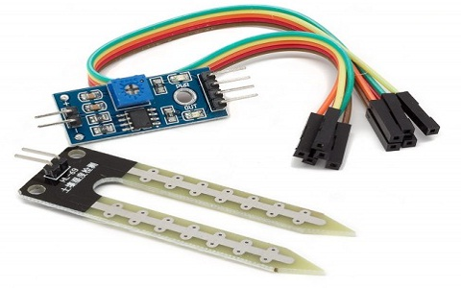

Fig 4.4 Soil Moisture Sensor

**Working Principle:**

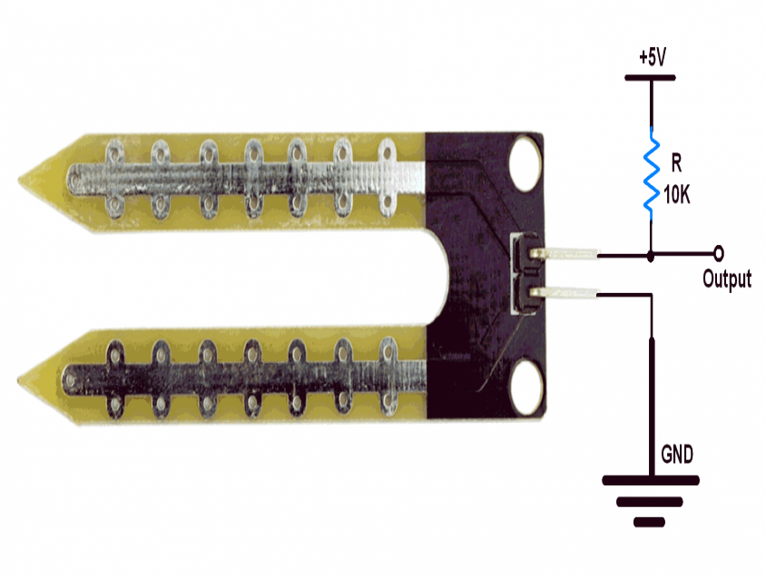

Fig 4.5 Working Diagram of Soil Moisture

The above figure 4.5 shows the working principle of the soil moisture sensor.

* Soil moisture sensor has two conducting plates. First plate is connected to the +5Volt supply through series resistance of 10K ohm and second plate is connected directly to the ground.
* It simply acts as a voltage divider bias network, and output is taken directly from the first terminal of the sensor pin, which is shown in figure above.
* The output will change in the range of 0 – 5 Volt, in proportion with change in content of water in the soil.
* Ideally, when there is zero moisture in soil, the sensor acts as open circuit i.e., infinite resistance. For this condition, we get 5V at the output.

**Specifications:**

* Operating Voltage: 3.3V to 5V DC
* Operating Current: 15mA
* Output Digital - 0V to 5V, Adjustable trigger level from preset
* Output Analog - 0V to 5V based on infrared radiation from fire flame falling on the sensor
* LEDs indicating output and power
* PCB Size: 3.2cm x 1.4cm
* LM393 based design.

**Applications:**

* Agriculture
* Landscape irrigation
* Research
* Simple sensors for gardeners

**4.5 DHT11 Sensor:**

The amount of water vapor in the air is measured as humidity. The amount of humidity in theair has an impact on a number of chemical, biological, and physical processes. Humidity canhave an impact on staff health and safety, business costs associated with the products, andemployee safety. So, measuring humidity is crucial in the semiconductor and control systemindustries. The amount of moisture in a gas which could be a mixture of water vapor,nitrogen, argon, or pure gas, for example is determined by its relative humidity. Based ontheir measuring units, humidity sensors can be divided into two categories. A relative humiditysensor and an absolute humidity sensor are what they are. A digital temperature and humiditysensor is the DHT11.

A cheap digital sensor for detecting humidity and temperature is the DHT11. To instantly measure humidity and temperature, this sensor can be easily interfaced with any microcontroller, including Arduino, Node MCU Raspberry Pi, etc. Both a sensor and a module are available for the DHT11 humidity and temperature sensor. The pull-up resistor and a power on LED distinguish this sensor from the module. A relative humidity sensor is the DHT11. This sensor employs a capacitive humidity sensor and a thermistor to measure the ambient air.

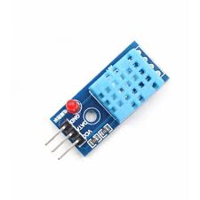

Fig 4.6 DHT11 Sensor

**Working Principle:** The DHT11 sensor comprises of a thermistor for measuring temperature and a capacitive humidity sensing device. The humidity detecting capacitor consists of two electrodes separated by a substrate that can hold moisture as a dielectric. The capacitance value changes as the humidity levels fluctuate. The IC calculates, interprets, and converts the modified resistance values into digital form. This sensor uses a negative temperature coefficient thermistor to measure temperature, which results in a decrease in resistance value as temperature rises. This sensor is typically made of semiconductor ceramics or polymers in order to obtain higher resistance values even for the smallest change in temperature. The DHT11 has a temperature range of 0 to 50 degrees Celsius with a 2-degree precision. This sensor has a 20 to 80% humidity range with a 5% accuracy. This sensor's sampling rate is 1Hz. In other words, it provides one reading per second. The DHT11 is a tiny device with a 3 to 5volt operational range. 2.5mA is the maximum current that can be used for measuring.

Four pins make up the DHT11 sensor: VCC, GND, Data Pin, and a Not Connected Pin. For communication between the sensor and microcontroller, a pull-up resistor of 5k to 10k ohms is offered.

**Specifications:**

Voltage Range: 3.5 to 5.5V

Operating current: (measuring) 0.3 mA 60 uA (standby)

Data output in serial

Range of temperatures: 0°C to 50°C

Range of Humidity: 20% to 90%

Temperature and humidity are both 16-bit resolutions.

Precision: 1°C and 1%

**Applications:**

* DHT11 Relative Humidity and Temperature Sensor can be used in many applications like:
* HVAC (Heating, Ventilation and Air Conditioning) Systems.
* Weather Stations.
* Medical Equipment for measuring humidity.
* Home Automation Systems.
* Automotive and other weather control applications.

**4.6 LDR Module:**

A low-cost digital and analogue sensor module called an LDR sensor module may measureand detect light intensity. The Photoresistor Sensor is another name for this sensor. An internalLDR (Light Dependent Resistor) on this sensor aids in the detection of light. This sensormodule comes with 4connections. where "AO" is an analogue output pin and "DO" is a digitaloutput pin. In the absence of light, the module's output increases, and in the presence of light,it decreases. The integrated potentiometer on the sensor allows the sensitivity to be changed.A potential divider is a circuit that consists of two resistors connected in series. While aconstant voltage is applied across both resistors, the output voltage from the lower resistor willbe measured. In this case, the lower resistor will be an LDR, and the constant voltage will be+5V.

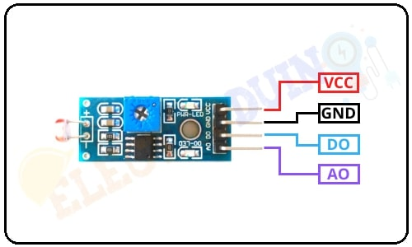

Fig 4.7 LDR Module

**Specifications:**

* Operating Voltage: DC 3.3 to 5
* 15 mA, Operating Current
* Output Digital: 0V to 5V; Output Analog: 0V to 5V;
* Adjustable Trigger Level: From Preset; Based on Light Falling on LDR LEDs Indicating Output and Power
* PCB Dimensions: LM393-based design, 3.2 cm by 1.4 cm.

**Working Principle:** One kind of variable resistor is the LDR, or Light Dependent Resistor. Another name for itis a photoresistor. The "Photo Conductivity" theory underlies the operation of the Light Dependent Resistor (LDR). The LDR resistance varies depending on the amount of light that hits it. The LDR resistance will drop and the element conductivity will increase as the light intensity increases on the LDR surface. The LDR resistance will rise and the element conductivity will fall as the light intensity decreases on the LDR surface. The integrated variable resistor or potentiometer of the LDR sensor module has a preset value of 10k. It is used to adjust the LDR sensor's sensitivity. To change the sensitivity of the light intensity detector, turn the preset knob. The sensitivity of the light intensity detection will enhance if we turn the preset knob in a clockwise manner. The light intensity detection's sensitivity would decline if it turned the other way around. The internal LED shows whether the power supply for the LDR sensor module is on or off. This Green LED also turns on when the sensor power supply is turned on. The green LED turns on when the LDR sensor senses light. The green LED turns off when the LDR sensor senses darkness.

The LDR sensor module must first be connected to a 5-volt power source. Then, by turning the preset knob for selecting the sensor sensitivity, set the threshold voltage at the non-Inverting input (3) of the IC in accordance with the current light intensity.

The resistance of the LDR diminishes as light intensity increases on its surface. The resistor will then get the greatest amount of voltage at that point (R3). As a result, the LDR's low voltage is applied to the IC's inverting input (2). The Comparator IC then evaluates this voltage in comparison to the threshold voltage. The sensor output becomes LOW when the input voltage falls below the threshold value in this circumstance (0).

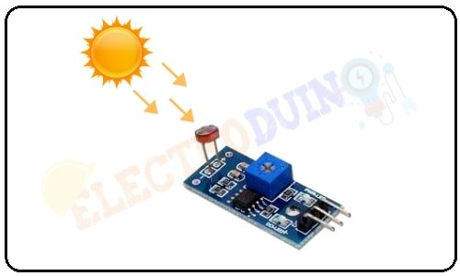

Fig 4.8 Working of IR sensor

On the other hand, the resistance of the LDR increases as light intensity (low/dark) decreases on its

surface. The LDR will then get the maximum amount of voltage (R2). As a result, the LDR's high voltage

is applied to the IC's inverting input (2). The Comparator IC then evaluates this voltage in comparison to

the threshold voltage. In this circumstance, the input voltage exceeds the threshold voltage, resulting in a

high sensor output (1).

**Applications:**

* LDRs are used in Light Sensors
* LDR is also used in some cameras to detect the presence of the light.
* LDRs are used Light Intensity measurement meters.
* In the manufacturing industry, LDR is used as a sensor for the counting of the packets moving on a conveyor belt.
* LDRs are also used in Light Activated Control Circuits.
* LDRs are used in Street Lights which are automatically turn ON in the night time.
* LDRs are used in Burglar Alarm Circuits.
* LDRs are used in Photosensitive Relays.
* LDR can be used in simple Fire alarm circuits.

**5. RESULTS**

In this project, Smart home automation system, Smart irrigation system & Automatic Street light controller system are implemented. Home automation system and irrigation system are implemented using Node MCU. Automatic street light controlling system is implemented using LDR module.

Following are the experimental design and results for the smart city project:

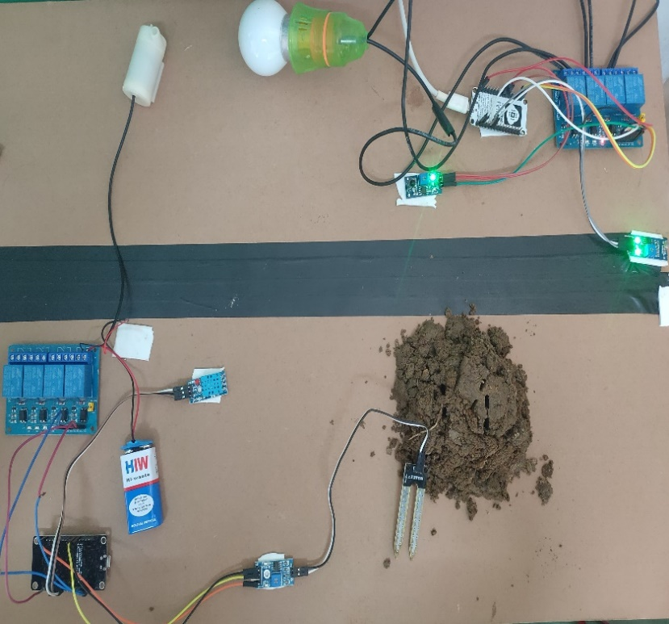

**Fig.5.1: Implementation of Smart City System**

Fig.5.1 illustrates how the smart city system was implemented with the help of Node MCU. The smart home automation system, smart irrigation system, and automatic street controller are the three components of the aforementioned diagram. Two four-input relays are employed in this project, one for the smart irrigation system and another for the home automation system & street light control system. Node MCU serves as the implementation's primary building block.

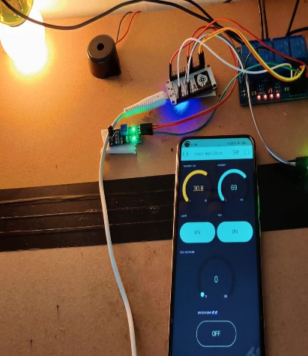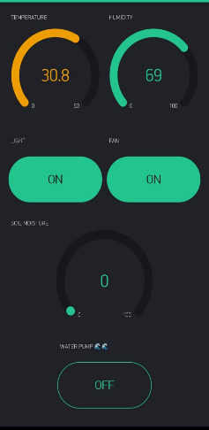



**Fig.5.2. (a) Fig.5.3. (b)**

**(a) Home Automation System; (b)Values of temperature & humidity in blynk app**

The above figure 5.2.(a) shows the implementation of home automation system. At an early age, the home appliances management was such as manually like turn on/off the appliances one has to go to the switchboard. It is good for normal people but an old age person and the physically disabled person cannot access it. By using home automation system, home appliances can be easily controlled with our smart phone using blynk application. From the above figure 5.2.(a) it is clearly observed that the appliances (light, fan…) can be controlled with our phone. This can be done from any location inside the house or from the outside. This project is able to manage a variety of appliances, but only using of four-input relay, allows us to control four appliances. In addition to these functions, a new feature has been added by employing a fire sensor (BS5839) to detect fires inside the home and a buzzer (which is encircled in fig.5.2. (a)) is provided for signaling purposes. This home automation system has several benefits, like the ability to control all of our home appliances from one location, flexibility for new appliances and gadgets, increased home security, improved energy efficiency, etc.



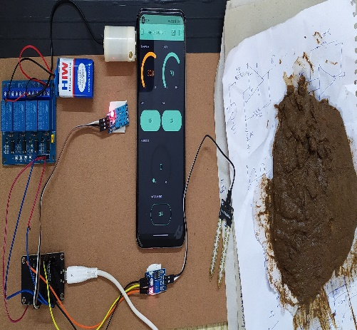 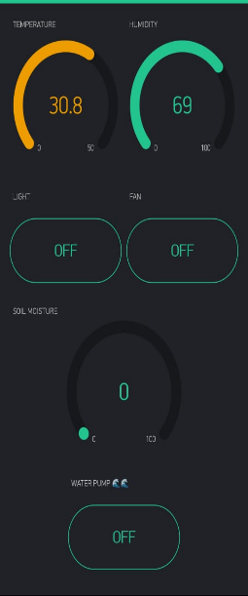

**Fig.5.4. (a) Fig.5.5. (b)**

**(a)Smart Irrigation System; (b) with zero moisture levels**

The implementation of a smart irrigation system is shown in fig.5.4. (a). DHT 11 and a soil moisture sensor (REES52) are utilized in this implementation. To determine the soil's moisture content, a soil moisture sensor is used, and a DHT 11 sensor is used to determine the temperature and humidity levels. Soil moisture sensors measure the water content in soil. Moisture in the soil is an important component in the atmospheric water cycle. Sensor module outputs a high level of resistance when the soil moisture is low. It has both digital and analog outputs. Digital output is simple to use, but it is not as accurate as analog output based on moisture level motor gets turn on/off automatically. In fig 5.5.(b), on a particular day the value of temperature is 30.8 degree centigrade and the value of humidity is 69%. The temperature and humidity values can change once we step outside. In fig.6.5. b, initially the pump motor is off, because dry soil has been taken which is free from moisture. When the soil is dry, its moisture content is too low. It is clearly observed in fig 5.4.(a) the moisture sensor is not buried in the soil. So, the value of moisture is zero which is clearly observed in fig 5.5.(b). This smart irrigation system can be extended to cultivation which will be more useful for the farmers. Different species of crops and plants needs different amount of water for effective irrigation. Vegetables, for instance, may fall between 60 and 70%. So, accordingly use this irrigation system for different crops and vegetables.

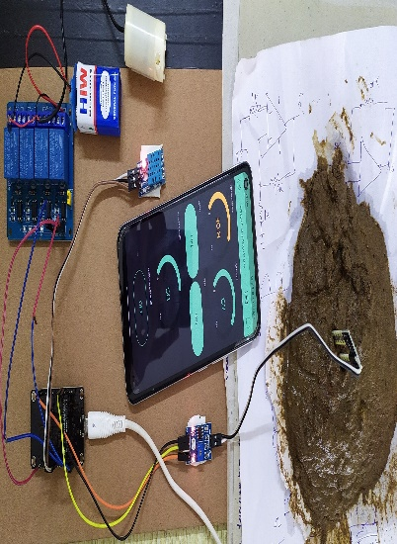 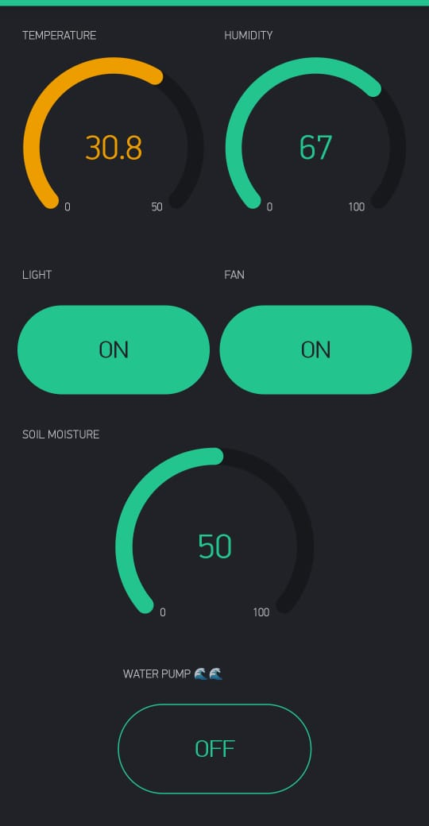

**Fig.5.6. (a) Fig.5.7. (b)**

**(a) Smart Irrigation System; (b) with moisture levels**

The dry soil has been moistened with some water in order to observe the soil's moisture content. After this, the moisture sensor is buried in the soil which is clearly shown in fig.5.6. (a). It is evident in fig.5.7. (b) that the soil has a 50% moisture content which can be observed in our phone through blynk application. If the value of the moisture content of the soil is known, then the irrigator can provide sufficient amount of water to plants. If the moisture content of the soil is not known, then the irrigator will end up watering the extra amount of water or will end up providing a little amount of water to the plants which will be not desirable, it will waste our water resources and will bring loss to the farmer as the using of irrigation system is expensive. By using our methodology water will be saved and farmers will be able to reduce the expenses which will be profitable to them and they will produce more from the appropriate amount of water.

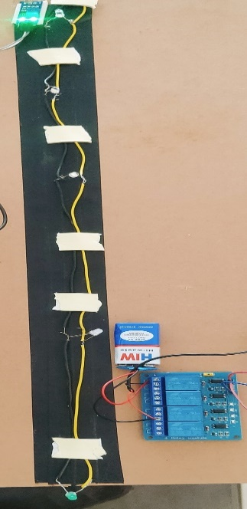 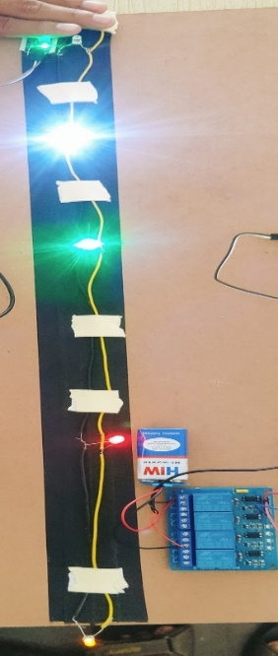

**Fig.5.8. (a) Fig.5.9. (b)**

**(a)Smart Street lights are turned off during day time (b) Smart Street lights are turned on during night**

The implementation of an automatic street light controller is shown in fig. 5.8.(a). This automatic controlling system is done using ldr module. Since the ldr module is exposed to sunlight, it is obvious that the street lights in fig.5.8. (a). is off because it is daytime. The ldr module measures light intensity; as it is higher during the day, street lights are automatically turned off. The ldr module in fig.5.9. (b) is not exposed to sunlight; hence the light intensity is modest. Street lights automatically come on at night since the intensity is lower. Since street lights are not necessary during the day, the LDR turns them off until the light level is low or the frequency of the light is low and the resistance of the LDR is high. In earlier days, there is no this type of automatic controlling of street lights, it completely depends on man power. There is a huge amount of power loss whenever the man forgot to turn off the street light. With the use of this system, leads to less power consumption, lower chances of overheating & risk of accidents are also minimized. There is no longer a need to keep an eye on the street lights once they are installed.

# 

# 6. CONCLUSION AND FUTURE WORK

In this project, we proposed and implemented the IoT-based smart city system using Node MCU, which is adaptable, affordable, secure and will function well over long distances. This project consists of three main sectors i.e.; Smart home automation system, Smart irrigation system, Automatic Street light controller. Smart home automation system is implemented to control our home appliances with our mobile phone which will be more useful for the old age people and handicapped people. Using, this system provides home security and improves quality of the life of the people. This system has many features and its cost is also very low compared to all other systems. The smart irrigation system is implemented to know the moisture content of the soil and accordingly provide sufficient amount of water to plants which saves water, money & time. This system is more useful for the farmers to reduce their expenses which will be profitable to them and they will produce more from the appropriate amount of water. The automatic street light controlling system is implemented to control the street lights automatically without using man power which leads to less power consumption, lower chances of overheating & risk of accidents are also minimized.

The future work of the proposed work is to include smart traffic system by introducing cloud inthe hospital management system and connecting to the traffic system so that every people patient can reach hospital with in less time which saves people life. Future work may focus on smart buildings with integrated sensors that reduce complexity.

# 

# APPENDIX

# REFERENCES

# [1] S. Kumar and S. R. Lee, ‘‘Android based smart home system with control via Bluetooth and Internet connectivity,’’ in Proc. 18th IEEE Int. Symp. Consum. Electron. (ISCE), Jun. 2014, pp. 1–2.

# [2] J. Jin, J. Gubbi, S. Marusic, and M. Palaniswami, ‘‘An information framework for creating a smart city through Internet of Things,’’ IEEE Internet Things J., vol. 1, no. 2, pp. 329–332, Apr. 2011.

# [3] M. A. E. L. Mowad, A. Fathy, and A. Hafez, ‘‘Smart home automated control system using Android application and microcontroller,’’ Int. J. Sci. Eng. Res., vol. 5, no. 5, pp. 935–939, May 2014.

# [4] A. Gluhak, S. Krco, M. Nati, D. Pfisterer, N. Mitton, and T. Razafindralambo, ‘‘A survey on facilities for experimental Internet of Things research,’’ IEEE Commun. Mag., vol. 49, no. 11, pp. 58–67, Nov. 2011.

# [5] Y.-L. Hsu, P.-H. Chou, H.-C. Chang, S.-L. Lin, S.-C. Yang, H.-Y. Su, C.-C. Chang, Y.-S. Cheng, and Y.-C. Kuo, ‘‘Design and implementation of a smart home system using multisensory data fusion technology,’’ Sensors, vol. 17, no. 7, p. 1631, Jul. 2017.

# [6] S. Pirbhulal, H. Zhang, M. E. E. Alahi, H. Ghayvat, S. C. Mukhopadhyay, Y. T. Zhang, and W. Wu, ‘‘A novel secure IoT-based smart home automation system using a wireless sensor network,’’ Sensors, vol. 17, no. 1, p. 69, Dec. 2017

# [7] S. Kumar, ‘‘Ubiquitous smart home system using Android application,’’ Int. J. Comput. Netw. Commun., vol. 6, no. 1, pp. 33–43, 2014.

# [8] S. Pasha, ‘‘Thingspeak based sensing and monitoring system for IoT with MATLAB analysis,’’ Int. J. New Technol. Res., vol. 2, pp. 19–23, Jun. 2016.

# [9] R. Piyare and S. R. Lee, ‘‘Smart home-control and monitoring system using smart phone,’’ in Proc. 1st Int. Conf. Converg. Appl. (ICCA), vol. 24, 2013, pp. 83–86.

# [10] Piyare, Rajeev, and M. Tazil. "Bluetooth based home automation system using cell phone." 2011 IEEE 15th International Symposium on Consumer Electronics (ISCE). IEEE, 2011.

# [11] Tanya Makkar, Harshvardhan Singh Rathore, Yogesh, Sanjay Kumar Dubey, “Dual Mode Self Controlled Irrigation System for Home”, vol.6, December 9,2020.

# [12] K. K. Namala, K. K. Prabhu A V, A. Math, A. Kumari and S. Kulkarni, "Smart irrigation with embedded system," 2016 IEEE Bombay Section Symposium (IBSS), Baramati, 2016, pp. 1-5.

# [13] S. B. Saraf and D. H. Gawal, "IoT based smart irrigation monitoring and controlling system," 2017 2nd IEEE International Conference on Recent Trends in Electronics, Information & Communication Technology (RTEICT), Bangalore, 2017, pp. 815-819.

# [14] W. Zhao, S. Lin, J. Han, R. Xu and L. Hou, "Design and Implementation of Smart Irrigation System Based on LoRa," 2017 IEEE Globecom Workshops (GC Wkshps), Singapore, 2017, pp. 1-6.

# [15] [Mannan J., M.](https://www.emerald.com/insight/search?q=Mannar%20Mannan%20J.), [S., K.S.](https://www.emerald.com/insight/search?q=Kanimozhi%20Suguna%20S.), [M., D.](https://www.emerald.com/insight/search?q=Dhivya%20M.) and [T., P.](https://www.emerald.com/insight/search?q=Parameswaran%20T.) (2021), "Smart scheduling on cloud for IoT-based sprinkler irrigation", [*International Journal of Pervasive Computing and Communications*](https://www.emerald.com/insight/publication/issn/1742-7371), Vol. 17 No. 1, pp. 3-19.

[16]A. Raziei and H. Mohsenian-Rad, "Optimal Demand Response Capacity of Automatic Lighting Control," Innovative Smart Grid Technologies (ISGT), 2013 IEEE PES, February 20, 2013, pp. 1-6

[17] "An Innovation in the Field of Street Lighting System with Cost and Energy Efficiency," Indian Journal of Science and Technology, Vol. 8(17), August 2015. Akshay Balachandran, Murali Siva, V. Parthasarathi, Surya, and Shriram K. Vasudevan.

**CONFORMATION LETTER**

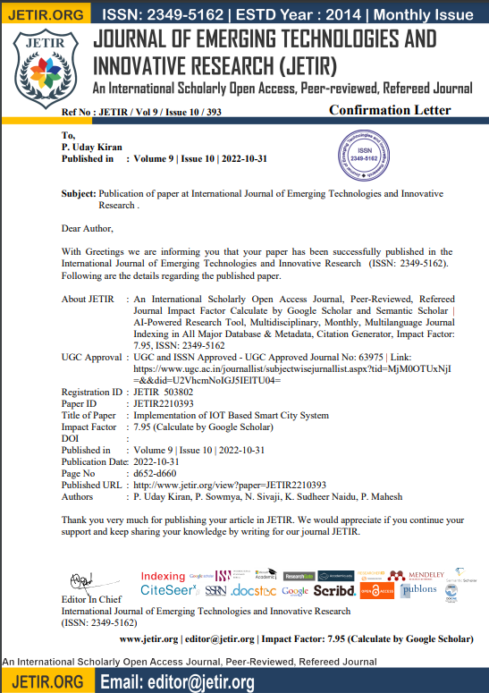

**PUBLICATION CERTIFICATES**



 

